Isoken Nwabunka Foundation Ignites Empowerment for Young Women's Entrepreneurial Growth
Stakeholders have emphasised the need to prioritise the empowerment of women for the sake of economic growth and development. This call was made during the unveiling of the Isoken Nwabunka Foundation and the launch of the book titled ‘Isoken’ in Lagos.
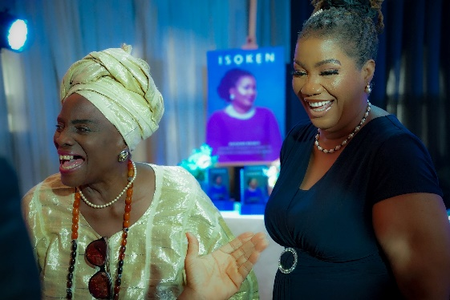
Veteran thespian, Taiwo Ajai-Lycett, shares a hilarious moment with Isoken Nwabunka, author of Isoken and Founder, Isoken Nwabunka Foundation.
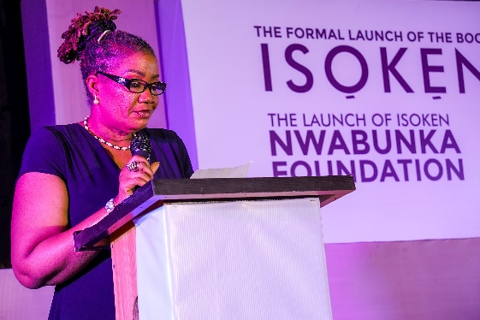
Isoken Nwabunka, author of 'Isoken' and Founder, Isoken Nwabunka Foundation, delivering her brief remarks at the event.
Isoken Patricia Nwabunka, the visionary leader and social entrepreneur, is the Founder of the Isoken Nwabunka Foundation. Mr. Soni Irabor, a seasoned broadcaster and Chairman of the Advisory Board of the Isoken Nwabunka Foundation, highlighted the importance of equipping women with knowledge and skills to enable their financial independence and contribute to economic growth.
Irabor described the foundation as a social enterprise dedicated to empowering young girls and women between the ages of 12 and 21. He stated that the foundation aimed to help them overcome the challenges of adolescence and young adulthood and nurture their potential to become productive, caring, and responsible citizens.
“Our objective is to create a supportive socio-economic structure, an organized community, where life skills, entrepreneurial principles, and resilience are instilled in these young women,” said Irabor.
He further explained that the Isoken Foundation project, inspired by the autobiography of Mrs. Isoken Nwabunka, aimed to provide a platform where young girls and women could receive guidance and support to navigate the trials of life and emerge as accomplished individuals.
“We believe in equipping them with the necessary tools to develop essential life skills, embrace entrepreneurial principles, and build the resilience necessary to thrive in the face of life's challenges,” Irabor added.
The foundation plans to establish Isoken Community Clubs in senior secondary schools and universities across the country. These clubs will provide members with a world-class club experience, motivating them to stay focused on their academic pursuits, develop future plans, and cultivate exemplary character and entrepreneurial attributes. Every club member will also receive a complimentary copy of the book ‘Isoken’ for inspiration and motivation.
During the event, Mrs. Delphine Misan-Arenyeka, the Managing Director of Grooming Microfinance Bank, delivered the keynote address. She emphasized the value and potential of girls and women in a country where gender equality is still a struggle. Misan-Arenyeka stated that empowering the female gender is essential for individual growth and national advancement.
“We can create a future where every Nigerian girl and woman can thrive, contribute, and lead by removing social barriers, promoting education and skills, and fostering inclusivity and support,” she said.
She commended the Isoken Nwabunka Foundation and the book ‘Isoken’ for their dedication to improving the lives of young girls and women in Nigeria, noting that empowerment and education are key to unlocking the nation's limitless potential.
The founder of the foundation, Nwabunka, shared her unwavering commitment to empowering young girls and women, which stems from her own life journey exemplifying wisdom, courage, and faith against all odds.
The book ‘Isoken’ serves as Nwabunka's autobiography, portraying her transformative journey from a challenging childhood in Benin to becoming the executive director of a leading microfinance institution in Nigeria.
The event attracted people from all walks of life, who came together to support the Isoken Nwabunka Foundation and celebrate the power of empowering young girls and women.

